Task to setup: Docker, Jenkins, Apache, Nginx, Apache Tomcat

Task 1: Install Docker
Purpose: Update the system packages.
Command
sudo yum update -y
Purpose: Install Docker.
Command
sudo yum install docker -y
Purpose: Start Docker service.
sudo systemctl start docker
Purpose: Enable Docker to start automatically after reboot.
Command
sudo systemctl enable docker
Purpose: Verify Docker installation.
Command
docker –version
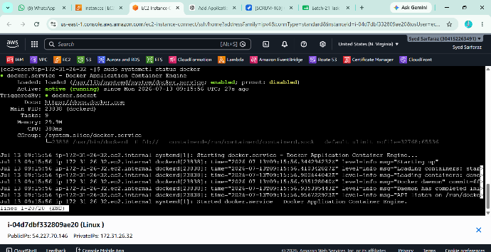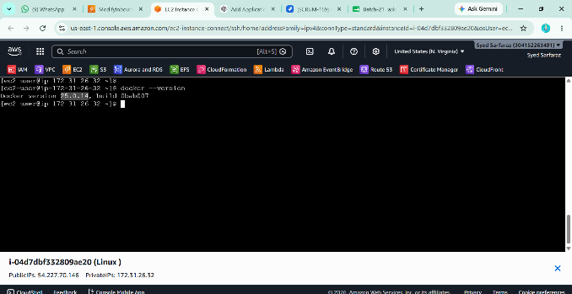

Task 2: Install Jenkins
Purpose: Install Java 21 (Required by latest Jenkins).
Command
sudo yum install java-21-amazon-corretto -y
Purpose: Verify Java installation.
Command
java -version
Expected Output
openjdk version "21"
Purpose: Add Jenkins repository.
Command
sudo wget -O /etc/yum.repos.d/jenkins.repo https://pkg.jenkins.io/redhat-stable/jenkins.repo
Purpose: Import Jenkins GPG key.
Command
sudo rpm --import https://pkg.jenkins.io/redhat-stable/jenkins.io-2023.key
Purpose: Install Jenkins.
Command
sudo yum install jenkins -y
Purpose: Reload systemd.
Command
sudo systemctl daemon-reload
Purpose: Start Jenkins.
Command
sudo systemctl start jenkins
Purpose: Enable Jenkins.
Command
sudo systemctl enable jenkins
Purpose: Verify Jenkins service.
Command
sudo systemctl status Jenkins
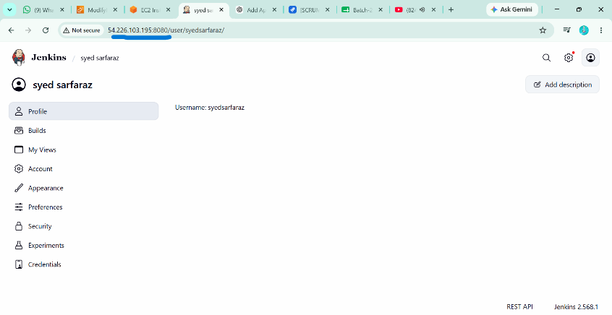

Task 3: Install Apache (httpd)
Purpose: Install Apache HTTP Server.
Command
sudo yum install httpd -y
Purpose: Start Apache.
Command
sudo systemctl start httpd
Purpose: Enable Apache.
Command
sudo systemctl enable httpd
Purpose: Verify Apache.
Command
sudo systemctl status httpd
Purpose: Change Apache port to 81.
Command
sudo vi /etc/httpd/conf/httpd.conf
Change
listen 80;
to
listen 81;
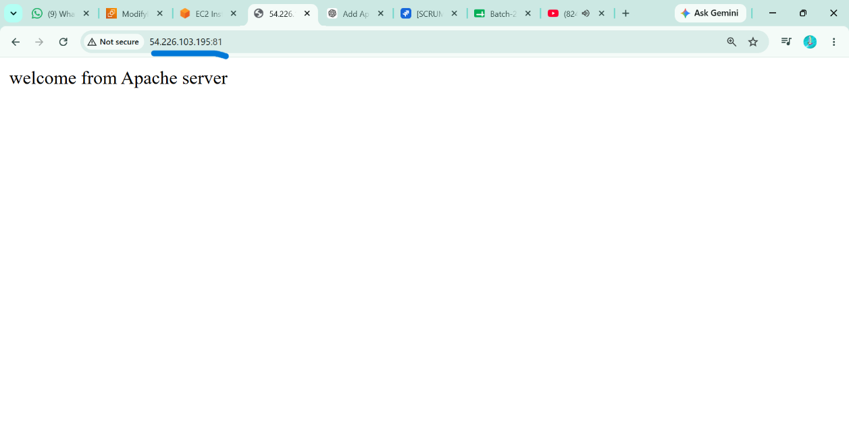

Task 4: Install Nginx
Purpose: Install Nginx.
Command
sudo amazon-linux-extras install nginx1 -y
Purpose: Change Nginx port to 82.
Command
sudo vi /etc/nginx/nginx.conf
Change
listen 80;
to
listen 82;
Purpose: Start Nginx.
Command
sudo systemctl start nginx
Purpose: Enable Nginx.
Command
sudo systemctl enable nginx
Expected Output
Purpose: Verify Nginx.
Command
sudo systemctl status nginx
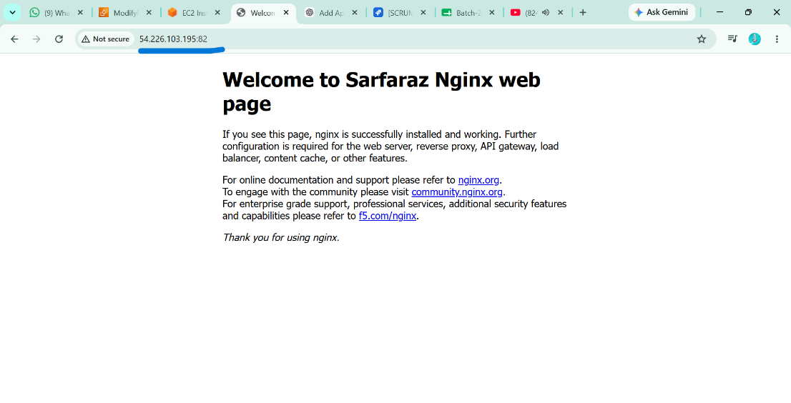

Task 5: Install Apache Tomcat
Purpose: Download Apache Tomcat 10.1.57.
Command
cd /tmp
wget https://dlcdn.apache.org/tomcat/tomcat-10/v10.1.57/bin/apache-tomcat-10.1.57.tar.gz
Expected Output
Saving to: apache-tomcat-10.1.57.tar.gz

Purpose: Create Tomcat installation directory.
Command
sudo mkdir -p /opt/tomcat

Purpose: Extract Tomcat.
Command
sudo tar -xzf apache-tomcat-10.1.57.tar.gz -C /opt/tomcat --strip-components=1

Purpose: Change Tomcat port to 8082.
Command
sudo vi /opt/tomcat/conf/server.xml
Change
Connector port="8080"
to
Connector port="8082"

Purpose: Start Tomcat.
Command
sudo /opt/tomcat/bin/startup.sh
Output
Tomcat started.

Purpose: Verify Tomcat.
Command
ps -ef | grep tomcat
Expected Output
tomcat ... org.apache.catalina.startup.Bootstrap start
